问题描述：装完docker后无法启动，显示Failed to start Docker Application Container Engine

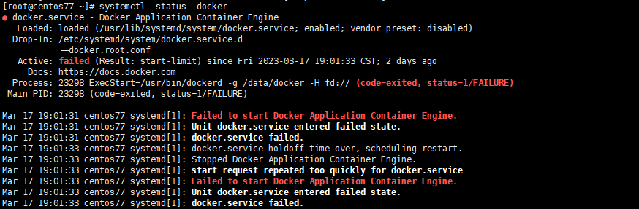

问题解决：

1. 根据提示journalctl -xe
2. 根据1没有得到有用的信息，进行手起dockerd

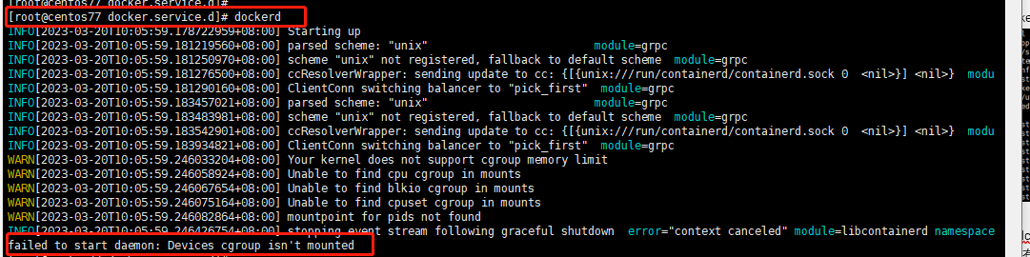

1. 看到消息，显示cgroup 未挂载。
2. 查看df -h ，确实没有cgourp 的挂载信息。
3. 进行手动挂载，运行脚本 1vim cgroup.sh 2chmod 777 cgroup.sh 3./cgroup.sh

#!/bin/bash

set -e

if grep -v '^#' /etc/fstab | grep -q cgroup; then

echo 'cgroups mounted from fstab, not mounting /sys/fs/cgroup'

exit 0

fi

# kernel provides cgroups?

if [ ! -e /proc/cgroups ]; then

exit 0

fi

# 确保目录存在

if [ ! -d /sys/fs/cgroup ]; then

exit 0

fi

# mount /sys/fs/cgroup if not already done

if ! mountpoint -q /sys/fs/cgroup; then

mount -t tmpfs -o uid=0,gid=0,mode=0755 cgroup /sys/fs/cgroup

fi

cd /sys/fs/cgroup

# get/mount list of enabled cgroup controllers

for sys in $(awk '!/^#/ { if ($4 == 1) print $1 }' /proc/cgroups); do

mkdir -p $sys

if ! mountpoint -q $sys; then

if ! mount -n -t cgroup -o $sys cgroup $sys; then

rmdir $sys || true

fi

fi

done

exit 0

6． systemctl daemon-reload && systemctl restart docker